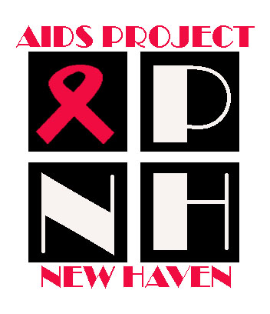 | AIDS Project New Haven  1302 Chapel Street  New Haven, CT 06511  Phone (203) 624-0947  Fax (203) 401-4457
Press Release
Contact: Jim Travers  Phone: (203) 624-0947, ext 229 | FOR IMMEDIATE RELEASE  9 A.M. EDT, March 30, 2007

Area AIDS supportive agencies struggle to provide services after learning of massive cuts in federal funding.

New Haven County, March 30, 2007: The consortium of AIDS supportive agencies met to discuss the devastation that will ensue at each of the agencies in light of the recent cuts in federal funding. Due to a change in the formula that allocates money to cities, New Haven was reduced to a lower funding tier. Even though the city exceeds the criteria for individuals who are HIV positive, the city fell just slightly below the guidelines for people living with AIDS. These statistics prove that the work done at these agencies are keeping people healthier by slowing the progression of the disease. Unfortunately, the necessary funding needed to keep these services available as been cut in half in New Haven County.

AIDS Project New Haven, AIDS Interfaith, Fair Haven Community Health Center, Hill Health Center, New Haven Home Recovery, Hispanos Unidos, Liberty Community Services, and the Yale Health Care van all support the approximately 1300 people living with HIV/AIDS in New Haven County.

The over 50% cut in funding has decreased primary care services. Additionally, the number of case managers who provide care and support has been drastically reduced. Furthermore, for many agencies transportation, alternative therapy, food service and meal delivery, mental health, substance abuse, education and outreach are either being suspended, eliminated, or drastically reduced. For the agencies that will be able to survive these funding cuts, their ability to provide primary support will be severely impacted.

All agencies remain committed to providing care; however, the effects of these funding cuts will undoubtedly affect the clients at these agencies. Each agency has begun to notify clients and families of the reduction or elimination of services that have kept them alive. If these agencies remain under-supported, the funding cuts will certainly have a lasting impact to our community.

The time is now to see the humanity behind the statistics and to ensure that Connecticut cities get priority when the supplemental money is distributed.

Representatives from these agencies will be available for interviews either individually or in a group. We need the support of the media to bring light to this issue.

AIDS Project New Haven Ellen Gabrielle 203.624.0947
AIDS Interfaith Mrs. Elsie Cofield 203.624.4350
Hispanos Unidos Luz Gonzalez 203.781.0226
Fair Haven Health Clinic Katrina Clark 203.786.6556
Hill Health Center Thomas Kidder 203.503.3148
Yale Heath Care Van Dr. Rick Altice 203.737.2883
New Haven Home Recovery Kelly Ann Day 203.492.4866
Liberty Community Services John Bradley 203.495.7600

Additionally, if you would like, I can coordinate a meeting of all the individuals listed above and host a meeting at AIDS Project New Haven. You may contact me at Jim Travers 203.624.0947 ext 229

