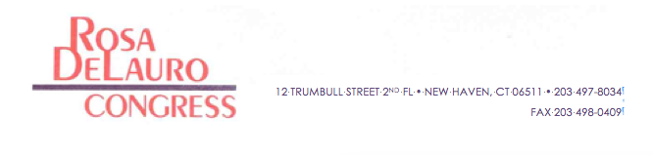
FOR IMMEDIATE RELEASE CONTACT: Kaelan Richards
September 9, 2011 (202) 225-3661

CONGRESSWOMAN ROSA DELAURO, D-3RD DISTRICT, ENDORSES NEW HAVEN MAYOR JOHN DESTEFANO FOR RE-ELECTION

New Haven, CT — Citing his exemplary record of fighting for New Haven’s working families, strengthening our economic competitiveness, and dramatically improving the city’s educational system, U.S. Rep. Rosa L. DeLauro, D-3rd District, today endorsed Mayor John DeStefano for re-election.

“Working and middle class families in Connecticut understand the challenges facing our state – an economy in transition, the skyrocketing costs to send their kids to college, to put a roof over their families’ heads, and most of all, to pay their bills, heat their homes and fill their gas tanks. In tackling these challenges, the people of New Haven need a proven leader with integrity, creativity, and innovation. They need John DeStefano,” said DeLauro, the co-chairman of the House Steering & Policy Committee, who has represented Connecticut’s 3rd Congressional District since 1990.

DeStefano, a lifelong resident of New Haven, has served as mayor since 1994, and is currently serving his 9th term in office.

“John DeStefano has led New Haven’s economic development: creating jobs, revitalizing our downtown, breaking down barriers and tapping our state’s vast supply of human and intellectual capital to attract new employers into the city. Most recently, I was very proud to work with him to secure $16 million in funding for the Downtown Crossing reclamation of Route 34, which will undo the division of New Haven's downtown, and is something I have been trying to accomplish my entire public life.

"In one of his most remarkable accomplishments, John has completely overhauled the city’s educational system, making New Haven one of the best, if not the best, urban school districts in America. During his tenure as mayor, virtually every single public school in the city has been rebuilt and renovated. He helped to negotiate a new contract with teachers’ unions that has become a national model of cooperation and reform. And, under the mayor's New Haven Promise program, every single New Haven graduate of public schools is now eligible to receive a free college education at in-state public universities. Education makes opportunity real for families, and no one understands that better than John DeStefano.

“The people of our city need a leader who has consistently shown that he will seize opportunities and tackle our toughest challenges head on. In John DeStefano, they see that leadership. They see a vibrant future for New Haven – rooted in a bold, new commitment to math and sciences that invigorates our public education system from elementary school to college. They see a workforce that will be the envy of the nation, attracting the kind of business investment that allows our communities to not only survive but thrive. It is an honor and a privilege to endorse my dear friend, John DeStefano, for another term as Mayor of New Haven.”

###

